**HTML Elements**

**Elements:**

An HTML **element** is defined by a start tag, some content, and an end tag.

The HTML **element** is everything from the start tag to the end tag:

**Syntax:**

<tagname>Content goes here...</tagname>

**Examples:**

<h1>My First Heading</h1>

<p>My first paragraph.</p>

<br>

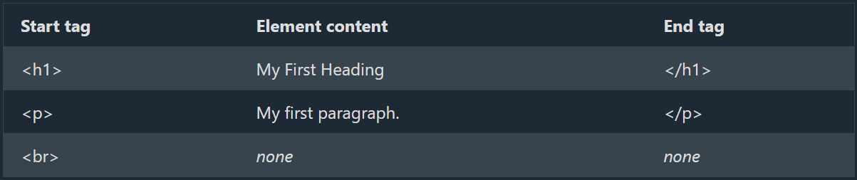

**Note:** Some HTML elements have no content (like the <br> element). These elements are called empty elements. Empty elements do not have an end tag!

**Nested HTML Elements:**

HTML elements can be nested (this means that elements can contain other elements).

All HTML documents consist of nested HTML elements.

The following example contains four HTML elements **(<html>, <body>, <h1>**and**<p>**):

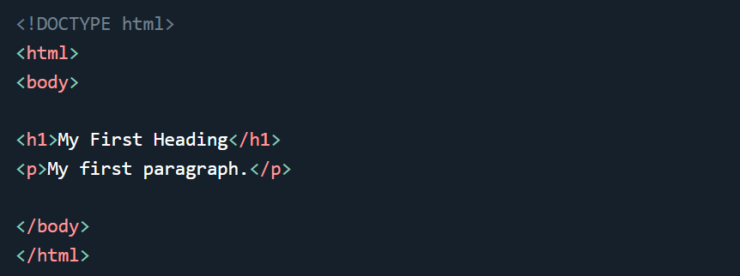

**Explanation:**

The **<html>** element is the root element and it defines the whole HTML document.

It has a start tag **<html>** and an end tag **</html>**.

Then, inside the **<html>** element there is a **<body>** element:

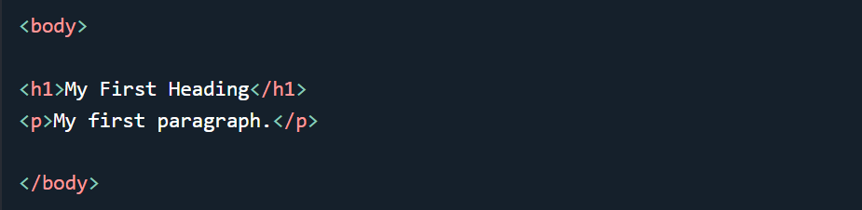

The **<body>** element defines the document's body.

It has a start tag **<body>** and an end tag **</body>.**

Then, inside the **<body>** element there are two other elements: **<h1>** and **<p>**:



The <h1> element defines a heading.

It has a start tag <h1> and an end tag </h1>:



The <p> element defines a paragraph.

It has a start tag <p> and an end tag </p>:



**Never Skip the End Tag:**

Some HTML elements will display correctly, even if you forget the end tag:

**Code:**

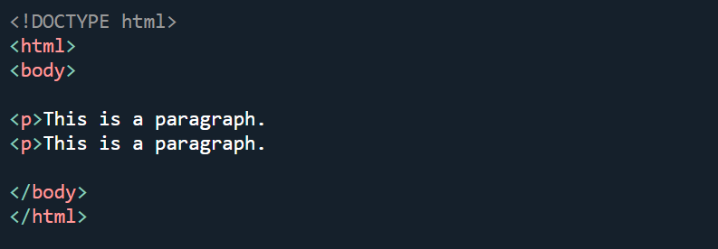

**Output:**

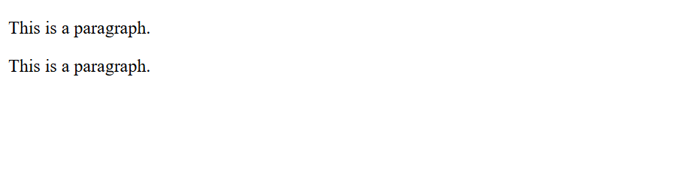

**Note:** However, never rely on this! Unexpected results and errors may occur if you forget the end tag!

**Empty HTML Elements:**

HTML elements with no content are called empty elements.

The <br> tag defines a line break, and is an empty element without a closing tag:

**Code:**

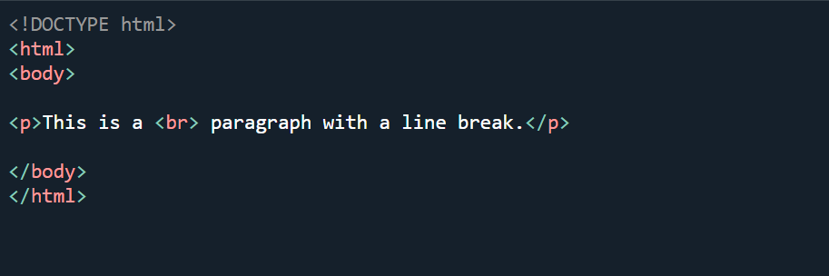

**Output:**

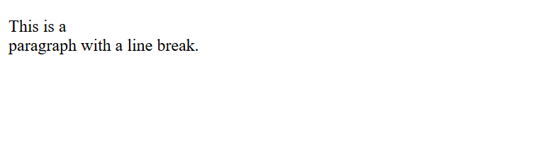

**HTML is Not Case Sensitive:**

HTML tags are not case sensitive: <P> means the same as <p>.

The HTML standard does not require lowercase tags, but W3C **recommends** lowercase in HTML, and **demands** lowercase for stricter document types like XHTML.

**HTML Tag Reference:**

W3Schools' tag reference contains additional information about these tags and their attributes.

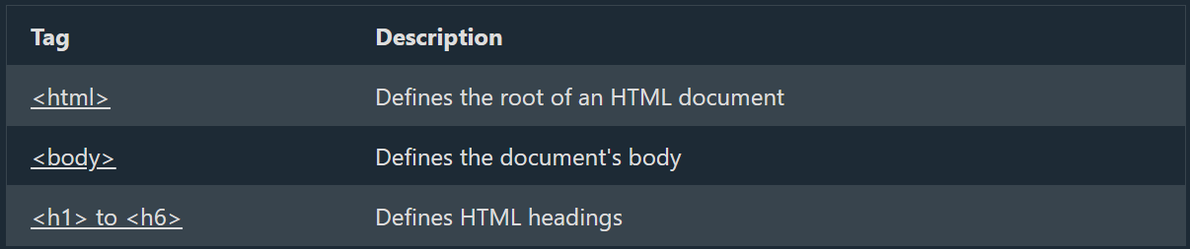

**Reference Links W3:**

HTML: <https://www.w3schools.com/tags/tag_html.asp>

Body: <https://www.w3schools.com/tags/tag_body.asp>

Heading: <https://www.w3schools.com/tags/tag_hn.asp>